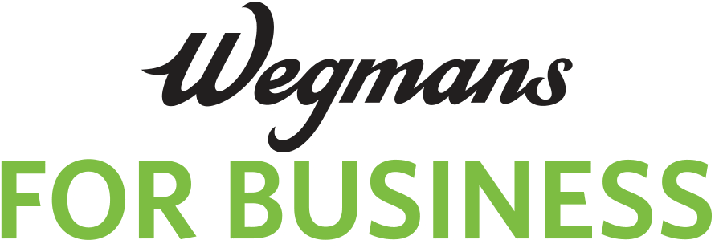

CHARGE APPLICATION – BUSINESS ACCOUNT

For-Profit Company

Must apply for Membership first
Already have a Membership account? Enter your account #_____________________

RETURN TO: WEGMANS FOR BUSINESS PO BOX 92217, ROCHESTER, NY 14692-0217
OR EMAIL BOTH PAGES TO: wegmanscharge@wegmans.com

LEGAL NAME |  |  | TRADE NAME/DBA
STREET ADDRESS |  |  | APPROX. MONTHLY CREDIT REQUESTED  (MINIMUM $1,000) : $
CITY |  |  | STATE |  |  |  |  | ZIP CODE
BUSINESS PHONE |  |  |  |  |  | EMAIL ADDRESS
TYPE OF BUSINESS (please circle one)  INDIVIDUAL PARTNERSHIP CORPORATION LLC |  |  |  |  | FED. TAX NO. (FOR CORP)
OWNERS/OFFICERS |  | HOME ADDRESS CITY,STATE,ZIP |  |  |  |  | HOME PHONE |  | TITLE

GENERAL INFORMATION
Are You Listed With  Dun & Bradstreet? |  |  |  | What Is Your Line of Business
Date Incorporated  Or Registered? |  |  |  | What Are Your Annual Sales?
Have You Ever Been In  Business Before? |  |  |  | Have You Ever Failed  In Business?
Have You Or Your Business  Ever Been Bankrupt? |  |  |  | Have Any Liens or Judgments Ever Been  Filed Against You Or Your Business?
IF THE ANSWER IS “YES” TO ANY OF THE ABOVE, STATE DETAILS, INCLUDING NAMES, ADDRESSES & DATES

TERMS AND CONDITIONS – THIS SECTION MUST BE COMPLETED BY ALL APPLICANTS

You represent that all the information you have provided in this application is accurate and that there are no material omissions. You authorize us to make whatever inquiries we deem necessary concerning this application. You further represent that no purchases made on the account will be for personal, family or household purposes. You further represent that the person signing below is authorized to sign agreements on behalf of the applicant. If you are approved for and issued a Charge Card, an Annual Fee of $100 will be charged to the Master Customer Billing Account address on record. The first Annual Fee will be assessed 90 days following the date your Charge Card is approved and issued to you and will be payable in full along with the other charges accrued on your Charge Card account for that month. Thereafter, your Annual Fee will be assessed each year in the same month that your initial Annual Fee is assessed. This Annual Fee is assessed only to the Master Customer Billing Account address on record and does not increase based on the number of accounts maintained or Charge Cards issued for that Master Account. You will be billed on the first business day of each month, at the address we have on record for your account, for all charges made during that month, and you agree to pay all charges on your Charge Card account within 20 days thereafter. If you do not, you will be in default and your account may be frozen if you fail to promptly pay the full account balance due. Also, you agree to pay $20.00 for each check that is returned unpaid. You will pay our costs, including reasonable attorney’s fees, if we have to collect an overdue balance from you. You are responsible for the security of the Charge Card(s) we issue to you and for promptly reviewing your billing statement each month. All charges made with Charge Cards issued to you will be deemed authorized by you up to and including the date you notify us that a Charge Card has been lost or stolen. We reserve the right to limit, cancel, or suspend your right to use your Charge Card(s) at any time for any reason. This agreement cannot be changed except by written notice from us to you, and your use of a Charge Card after being notified of a change indicates your acceptance of the change. You may not assign this agreement except with our express written consent. This agreement is governed by the laws of the State of New York without regard to principles of conflicts of laws. All disputes concerning this account shall be heard in a city, state or Federal court located in Monroe County, New York, and each party hereby consents to the jurisdiction of said courts.

X_____________________________________________________________________________________ Signature of Company’s Authorized Representative Printed Name Title Date

PERSONAL GUARANTY
This section MUST BE COMPLETED if your company is a corporation, limited partnership or limited liability company AND has less than $3 Million in annual sales OR is less than 5 years old.

The undersigned individually and unconditionally guarantee(s) the prompt and full payment to Wegmans Food Markets, Inc., its successors and assigns, of all amounts due on this account. This is a continuing guaranty and covers all amounts that are now due or may in the future become due to the account. No change in the agreement with the account holder or any payment or other arrangements made with the account holder, will affect this guarantee. The liability imposed by this guaranty is joint and several. The undersigned agree(s) to pay all our costs, including attorney’s fees, incurred to enforce this guaranty. The use of a business title next to the signature does not change the individual’s liability under the guaranty.
X _____________________________________________________________________________________
Signature Printed Name Date

X _____________________________________________________________________________________
Signature Printed Name Date

X _____________________________________________________________________________________
Signature Printed Name Date

X _____________________________________________________________________________________
Signature Printed Name Date

